Lab – Troubleshoot LAN Traffic Using SPAN

1. Topology

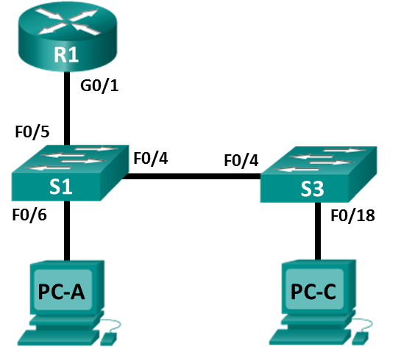

1. Addressing Table

|  |  |  |  |  |
| --- | --- | --- | --- | --- |
| Device | Interface | IP Address | Subnet Mask | Default Gateway |
| R1 | G0/1 | 192.168.1.1 | 255.255.255.0 | N/A |
| S1 | VLAN 1 | 192.168.1.2 | 255.255.255.0 | 192.168.1.1 |
| S3 | VLAN 1 | 192.168.1.3 | 255.255.255.0 | 192.168.1.1 |
| PC-A | NIC | 192.168.1.254 | 255.255.255.0 | 192.168.1.1 |
| PC-C | NIC | 192.168.1.10 | 255.255.255.0 | 192.168.1.1 |

1. Objectives

Part 1: Build the Network and Verify Connectivity

Part 2: Configure Local SPAN and Capture Copied Traffic with Wireshark

1. Background / Scenario

As the network administrator you decide to analyze the internal local area network for suspicious network traffic and possible DoS or reconnaissance attacks. To do this, you will set up port mirroring on all active switchports and mirror/copy all traffic to a designated switchport where a PC running Wireshark can analyze the captured traffic. The goal is to identify the source of suspicious traffic. To set up port mirroring you will use the Switched Port Analyzer (SPAN) feature on the Cisco switch.. It is common to find a device running a packet sniffer or Intrusion Detection System (IDS) connected to the mirrored port.

**Note**: The routers used with CCNA hands-on labs are Cisco 1941 Integrated Services Routers (ISRs) with Cisco IOS Release 15.2(4)M3 (universalk9 image). The switches used are Cisco Catalyst 2960s with Cisco IOS Release 15.0(2) (lanbasek9 image). Other routers, switches, and Cisco IOS versions can be used. Depending on the model and Cisco IOS version, the commands available and output produced might vary from what is shown in the labs. Refer to the Router Interface Summary Table at the end of this lab for the correct interface identifiers.

**Note**: Make sure that the routers and switches have been erased and have no startup configurations. If you are unsure, contact your instructor.

1. Required Resources

* 1 Router (Cisco 1941 with Cisco IOS Release 15.2(4)M3 universal image or comparable)
* 2 Switches (Cisco 2960 with Cisco IOS Release 15.0(2) lanbasek9 image or comparable)
* 2 PCs (Windows 8, 7, or Vista with a terminal emulation program, such as Tera Term or PuTTY, Wireshark, and Zenmap)
* Console cables to configure the Cisco IOS devices via the console ports
* Ethernet and serial cables as shown in the topology

1. Build the Network and Verify Connectivity

In Part 1, you will set up the network topology and configure basic settings, such as the interface IP addresses, static routing, device access, and passwords.

* 1. Cable the network as shown in the topology.

Attach the devices as shown in the topology diagram, and cable as necessary.

* 1. Configure PC hosts.
  2. Initialize and reload the routers and switches as necessary.
  3. Configure basic settings for the router.
     1. Disable DNS lookup.
     2. Configure the device name as shown in the topology.
     3. Configure an IP address for the router as listed in the Addressing Table.
     4. Assign **class** as the encrypted privileged EXEC mode password.
     5. Assign **cisco** for the console and vty password, enable login.
     6. Set the vty lines to **transport input telnet**
     7. Configure **logging synchronous** to prevent console messages from interrupting command entry.
     8. Copy the running configuration to the startup configuration.
  4. Configure basic settings for each switch.
     1. Disable DNS lookup.
     2. Configure the device name as shown in the topology.
     3. Assign **class** as the encrypted privileged EXEC mode password.
     4. Configure IP addresses for the switches as listed in the Addressing Table.
     5. Configure the default gateway on each switch.
     6. Assign **cisco** for the console and vty password and enable login.
     7. Configure **logging synchronous** to prevent console messages from interrupting command entry.
     8. Copy the running configuration to the startup configuration.
  5. Verify connectivity.
     1. From PC-A, you should be able to ping the interface on R1, S1, S3, and PC-C. Were all pings successful? ______________

If the pings are not successful, troubleshoot the basic device configurations before continuing.

* + 1. From PC-C, you should be able to ping the interface on R1, S1, S3, and PC-A. Were all pings successful? ______________

If the pings are not successful, troubleshoot the basic device configurations before continuing.

1. Configure Local SPAN and Capture Copied Traffic with Wireshark

To configure Local SPAN, you need to configure one or more source ports called monitored ports, and a single destination port, also called a monitored port, for copied or mirrored traffic to be sent out of. SPAN source ports can be configured to monitor traffic in either ingress, or egress, or both directions (default).

* 1. Configure SPAN on S1.
     1. Locate the switchports that are up on S1

S1# **show ip interface brief**

Which switchports are physically up and logically up? _____________________________________

On S1, F0/6 connects to PC-A which will be used for analyzing traffic with Wireshark. F0/6 will be the SPAN destination monitor port for duplicated packets. F0/4 and F0/5 will be the source monitor ports for intercepted packets. You can configure multiple source monitor ports but only one destination monitor port.

S1(config)# **monitor session 1 source interface f0/4 - 5**

S1(config)# **monitor session 1 destination interface f0/6**

* 1. Start a Wireshark Capture on PC-A.
     1. Open Wireshark on PC-A, set the capture interface to the Local Area Connection and click Start.

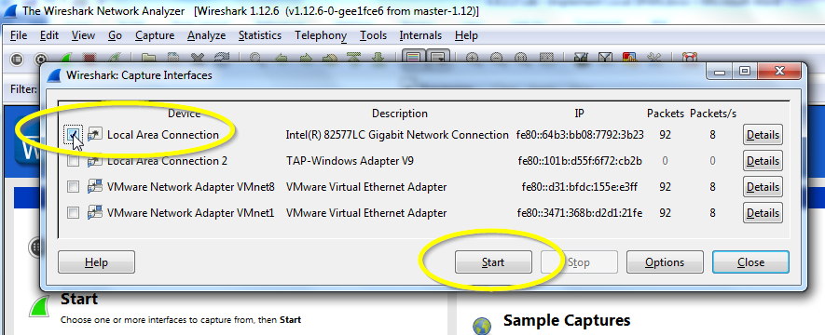

* 1. From PC-C Use NMAP to Generate Suspicious Traffic.
     1. Open Zenmap on PC-C and run a UDP ping scan to scan for available hosts (*nmap –sn –PU 192.168.1-6*). The scan result identifies 3 hosts on the network R1, S1, and S2 at 192.168.1.1, 192.168.1.2 and 192.168.1.3. Notice that Zenmap has also identified the MAC addresses of the three hosts as Cisco Systems interfaces. If this were a real network reconnaissance attack the scan might involve the entire range of network hosts as well as ports and OS fingerprinting.

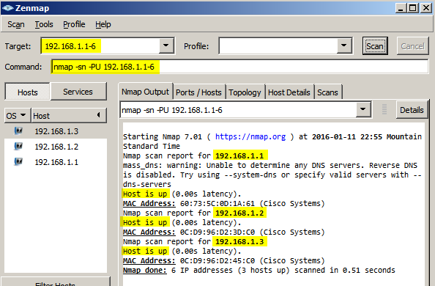

* + 1. The hypothetical attacker can now issue an intense scan on R1 at 192.168.1.1 (nmap –T4 –A –v 192.168.1.1). The scan result identifies an open port 23/Telnet.

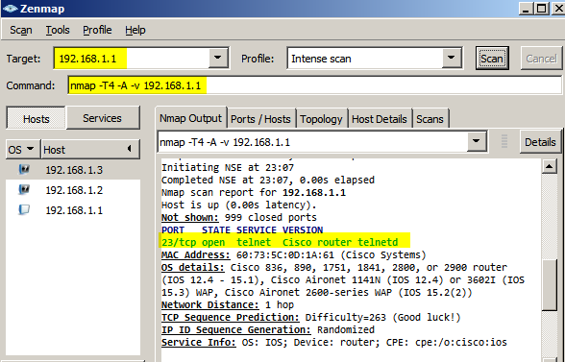

* 1. From PC-A Stop the Wireshark Capture and Examine the Captured SPAN Packets.
     1. Return to PC-A, and stop the Wireshark capture. Notice the non-standard traffic patterns between PC-C at 192.168.1.10 and R1 at 192.168.1.1. It is filled with Out-Of-Order segments and Connection resets (RST). This packet capture identifies PC-C as sending suspicious traffic to router R1.

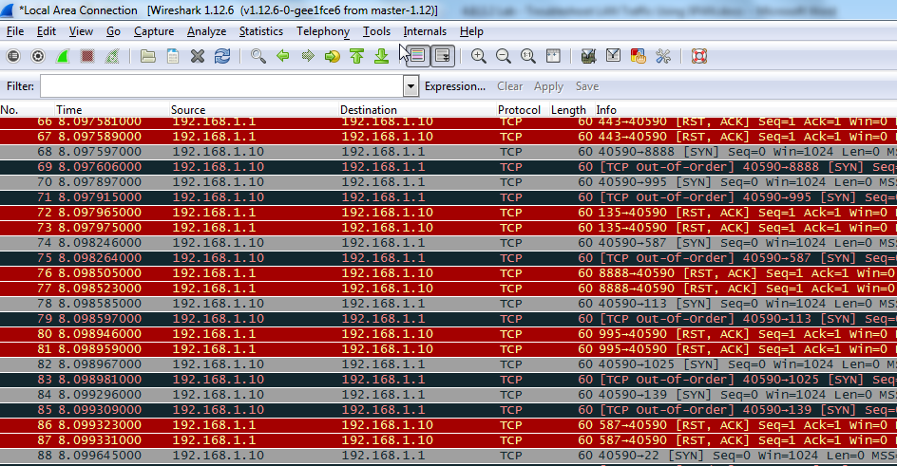

* + 1. The attacker on PC-C knowing that the router has an open port on 23 could attempt an additional brute force attack or DoS style attack, like a LAND attack. A LAND attack is a TCP SYN packet with the same source and destination IP address and port number. Using Zenmap, the command **nmap –sS 192.168.1.1 –S 192.168.1.1 –p23 –g23 –e eth0** is an example. Notice how the LAND attack sets both the source and destination IP addresses to 192.168.1.1 and both the source and destination port numbers to the open port at 23. Although R1 with IOS15 is not vulnerable to this older type of DoS attack, many older systems and servers are still vulnerable. This attack will crash vulnerable systems, by setting them into an infinite loop.

1. Reflection

In this scenario, SPAN was used to troubleshoot and identify the source of suspicious activity on the network? What other troubleshooting scenarios might SPAN be useful for?

_______________________________________________________________________________________

_______________________________________________________________________________________

1. Router Interface Summary Table

|  |  |  |  |  |
| --- | --- | --- | --- | --- |
| Router Interface Summary | | | | |
| Router Model | Ethernet Interface #1 | Ethernet Interface #2 | Serial Interface #1 | Serial Interface #2 |
| 1800 | Fast Ethernet 0/0 (F0/0) | Fast Ethernet 0/1 (F0/1) | Serial 0/0/0 (S0/0/0) | Serial 0/0/1 (S0/0/1) |
| 1900 | Gigabit Ethernet 0/0 (G0/0) | Gigabit Ethernet 0/1 (G0/1) | Serial 0/0/0 (S0/0/0) | Serial 0/0/1 (S0/0/1) |
| 2801 | Fast Ethernet 0/0 (F0/0) | Fast Ethernet 0/1 (F0/1) | Serial 0/1/0 (S0/1/0) | Serial 0/1/1 (S0/1/1) |
| 2811 | Fast Ethernet 0/0 (F0/0) | Fast Ethernet 0/1 (F0/1) | Serial 0/0/0 (S0/0/0) | Serial 0/0/1 (S0/0/1) |
| 2900 | Gigabit Ethernet 0/0 (G0/0) | Gigabit Ethernet 0/1 (G0/1) | Serial 0/0/0 (S0/0/0) | Serial 0/0/1 (S0/0/1) |
| **Note**: To find out how the router is configured, look at the interfaces to identify the type of router and how many interfaces the router has. There is no way to effectively list all the combinations of configurations for each router class. This table includes identifiers for the possible combinations of Ethernet and Serial interfaces in the device. The table does not include any other type of interface, even though a specific router may contain one. An example of this might be an ISDN BRI interface. The string in parenthesis is the legal abbreviation that can be used in Cisco IOS commands to represent the interface. | | | | |